NETWORK SECURITY, MAINTENANCE AND TROUBLESHOOTING PROCESS

DAY2
TASK1: In Cisco Packet Tracer, set up a simple network with one DHCP server and two client PCs. Configure the DHCP server to assign IP addresses automatically, then verify on each PC that it receives a different IP address from the DHCP pool.
- Open Cisco Packet Tracer.
- Create a new project.
- Add the following devices:
- 1 Switch (2960)
- 1 Server
- 2 PCs
4.Connect all devices to the switch using Copper Straight-Through cables.
5.Click on the Server.
6.Go to Desktop → IP Configuration.
7.Assign a static IP:
- IP Address: 192.168.1.2
- Subnet Mask: 255.255.255.0
- Default Gateway: 192.168.1.1
8.Go to Services → DHCP.
9.Turn DHCP Service ON.
10.Configure:
- Pool Name: LAN
- Default Gateway: 192.168.1.1
- DNS Server: 8.8.8.8
- Start IP Address: 192.168.1.100
- Subnet Mask: 255.255.255.0
- Maximum Users: 10
11.Click Save.
12.Click PC0 → Desktop → IP Configuration.
13.Select DHCP.
14.Repeat the same steps for PC1.
15.Both PCs will automatically receive different IP addresses.
OUTPUT:
Device | Assigned IP Address
PC0 | 192.168.1.100
PC1 | 192.168.1.101

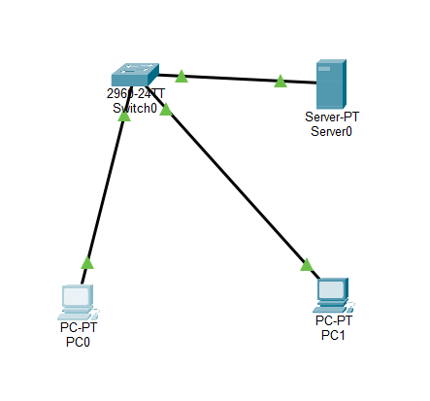
TASK2: Draw a sequence diagram (hand-drawn or digital) that clearly shows each step of the DHCP process: Discover, Offer, Request, and Acknowledge, labeling the sender and receiver at each stage.<br><br><em><strong>Hint:</strong> Use arrows to show the direction of each message between client and server.</em>

EXPLANATION:
- Discover – The client searches for a DHCP server.
- Offer – The server offers an available IP address.
- Request – The client requests the offered IP.
- Acknowledge – The server confirms and assigns the IP address.
TASK3: Change the DHCP pool range on your Cisco Packet Tracer DHCP server so that only one IP address is available. Add two PCs and observe what happens when both try to get an IP address. Take a screenshot of the result and explain in 2-3 lines why only one PC succeeds.
- Open your existing Packet Tracer project.
- Click the Server.
- Go to Services → DHCP.
- Change:
- Start IP Address: 192.168.1.100
- Maximum Users: 1
5.Click Save.
6.Add 2 PCs to the network.
7.Connect both PCs to the switch.
8.On both PCs, go to Desktop → IP Configuration.
9.Select DHCP.
10.Observe the IP addresses assigned.
Device | IP Address
PC0 | 192.168.1.100
PC1 | 0.0.0.0 (No IP Assigned)

TASK4: Simulate a Zomato-style restaurant WiFi scenario in Cisco Packet Tracer: configure a DHCP server to provide IP addresses to both a laptop and a smartphone (use a generic PC as smartphone). Show the assigned IPs and explain why DHCP is useful in this situation.
- Open Cisco Packet Tracer.
- Add the following devices:
- 1 Wireless Router
- 1 Laptop (PC)
- 1 PC (Use this as a smartphone)
3.Connect the devices to the wireless router.
4.Click the Wireless Router.
5.Go to GUI → Setup.
6.Enable DHCP.
7.Configure:
- Router IP: 192.168.0.1
- Start IP: 192.168.0.100
- Maximum Users: 10
8.Click Save Settings.
9.On the Laptop, go to Desktop → IP Configuration and select DHCP.
10Repeat the same for the PC (Smartphone).
11.Both devices will receive IP addresses automatically.
Device | Assigned IP
Laptop | 192.168.0.100
Smartphone (PC) | 192.168.0.101

